EXERCISE 1: CONTROL STRUCTURES
Scenario 1: Apply 1% discount to loan interest rates for customers above 60 years of age.
Code:
BEGIN
FOR c IN (
SELECT CustomerID,
FLOOR(MONTHS_BETWEEN(SYSDATE, DOB)/12) AS Age
FROM Customers
)
LOOP
IF c.Age > 60 THEN
UPDATE Loans
SET InterestRate = InterestRate - 1
WHERE CustomerID = c.CustomerID;
END IF;
END LOOP;

COMMIT;
END;
/

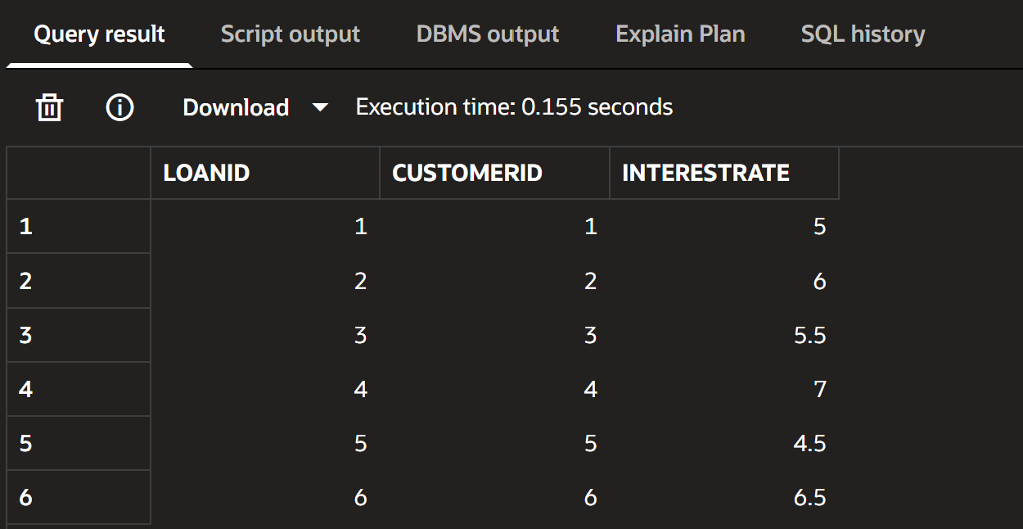

SELECT * FROM Customers;
SELECT * FROM Loan;
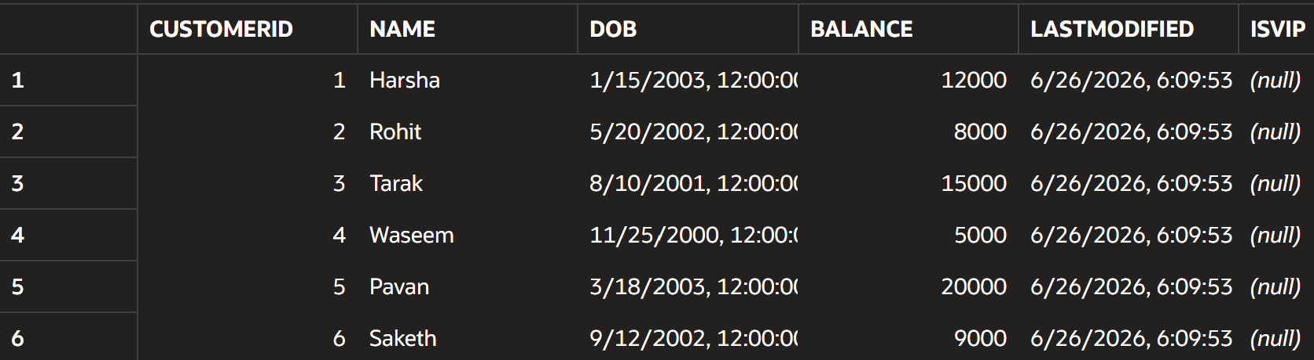

Scenario 2: Set IsVIP flag for customers with balance greater than 10000.
Code:
BEGIN
FOR c IN (
SELECT CustomerID, Balance
FROM Customers
)
LOOP
IF c.Balance > 10000 THEN
UPDATE Customers
SET IsVIP = 'TRUE'
WHERE CustomerID = c.CustomerID;
ELSE
UPDATE Customers
SET IsVIP = 'FALSE'
WHERE CustomerID = c.CustomerID;
END IF;
END LOOP;

COMMIT;
END;
/
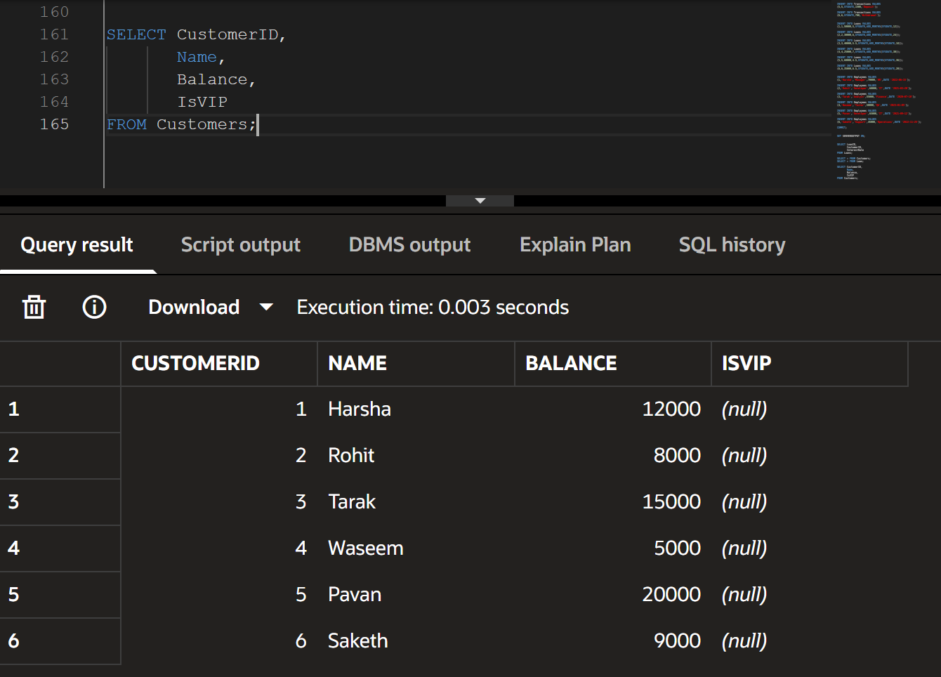

Scenario 3: Display reminders for loans due within the next 30 days.
Code:
SET SERVEROUTPUT ON;

BEGIN
FOR r IN (
SELECT c.Name, l.EndDate
FROM Customers c
JOIN Loans l
ON c.CustomerID = l.CustomerID
WHERE l.EndDate BETWEEN SYSDATE AND SYSDATE + 30
)
LOOP
DBMS_OUTPUT.PUT_LINE(
'Reminder: Loan due for ' || r.Name
);
END LOOP;
END;
/
Output:

Reminder: Loan due for Harsha

